15-112 Term Project Competitive Analysis

Shaojie Bai

One of the games on the Internet close to the **Cellular War** that I am making is the "Cloud War"--- though it is a bit easier. The game "Cloud War" can be found at the website below:

<http://www.kanogames.com/play/game/cloud-wars>

And here is one of the screenshots I take of the game:

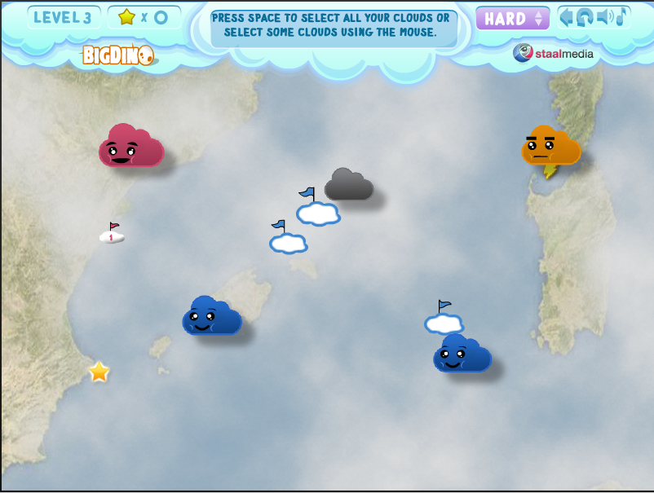

Figure 1. Cloud War

There are a few very good features that will be quite useful to my game design:

(1) When you drag a mouse from one cloud to the other, a blue line "travels" with the arrow such that it is easier for users to see what is going to be the target.

(2) As a cloud becomes stronger, its size gets larger. I am considering something similar, but using color instead.

(3) It has a good Artificial Intelligence (AI) in that the enemy cloud can attack the neutral / (my) friendly cloud with clever decisions.

However, the types of cloud are too simple, and the interface is not as satisfactory as I expected. After the first week's work, I realize that it may be much harder than I expected to have wave-like motion of the tentacles. Therefore, I choose to use straight-line chain with signals running on it.

Also, I plan to add physical movement with proper consideration of physics. This is to construct a better user-end experience. For example, for the EMB cell that is mobile, its movement should be smooth, which requires the consideration of acceleration. Unlike this game that I find above, the movement of the object (cell, in my case) is an added feature.

Moreover, I will add simple doodle-like animation on each "ATT" cell that I have. As I also have in my Term Project Proposal, the curly tentacles of cell is actually made by shifting among several images. This creates a "fake" animation effect :) In the end, as my mentor suggested, I may add the feature that indicate the life value of the cell, in form of liquid-representation. In other words, a full-life cell will be in full mono-color. But if a cell has not reached the max life limit, or if its life is decreasing, I can possibly make its color fading.